**Receiving**

**Page Load**

To start the process, all outstanding orders are displayed to the receiver.

Display the following for outstanding orders:

* Purchase Order Number
* Order Date
* Vendor Name
* Vendor Contact Phone
* The PurchaseOrderID (invisible)

**Outstanding Orders** (<asp:GridView>)

// Receiving Controller Class

[DataObjectMethod(DataObjectMethodType.Select)]

public List<OutstandingOrder> ListOutstandingOrders()

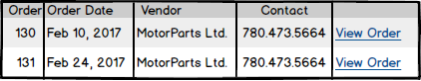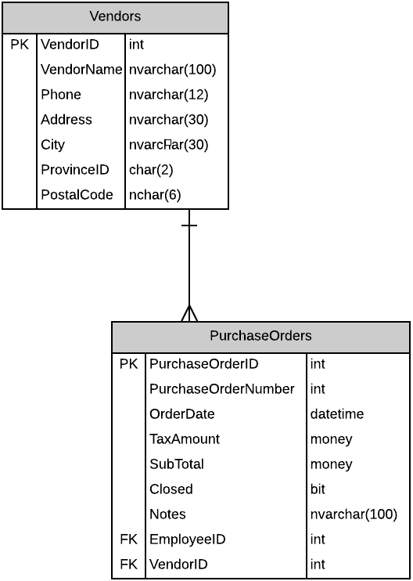

**Retrieve Outstanding Purchase Orders**

When the order is retrieved display:

* Purchase Order Number
* Vendor Name
* Vendor Contact Phone
* Purchase Order Details (for each detail)
  + Display
    - PurchaseOrderID (hidden)
    - PartID
    - Part Description
    - Quantity On Order
    - Quantity Outstanding

// Using the page’s code behind

**Display Vendor Info** (<asp:Label>)

protected void DisplayOrder_Click(object sender, EventArgs e)

// Receiving Controller Class

**Display Purchase Order Details** (<asp:GridView>)

[DataObjectMethod(DataObjectMethodType.Select)]

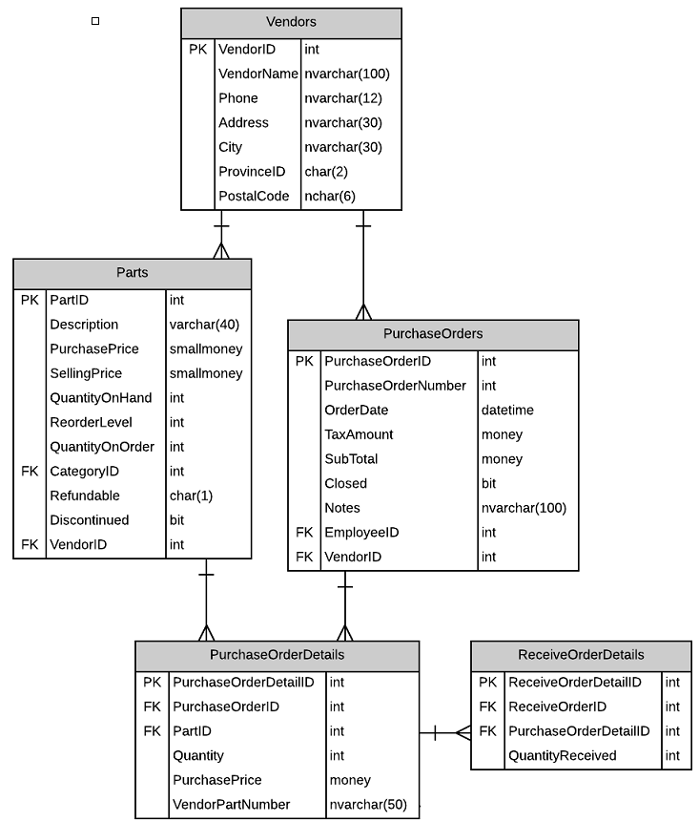public List<PurchaseOrderDetail> GetPurchaseOrderDetails(int purchaseOrderId)

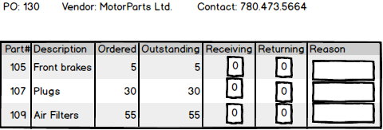

**Unordered Parts**

Receiver will process Unordered Purchase Items by:

* An unordered purchase item is a vendor part sent but was not part of the purchase order.
* Receiver will enter Decription, VendorPartNumber and Quantity for recording
* Records will be collected into a cart for processig with the rest of the received items
* Cart collected records for this receiving session will be displayed in a list as they are entered into the cart.

**Display Unordered Vendor Parts** (<asp:GridView>)

// Receiving Controller Class

//Display Unordered Vendor Parts

[DataObjectMethod(DataObjectMethodType.Select)]

public List<UnorderedPart> GetUnorderedParts(int purchaseOrderNumber)

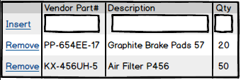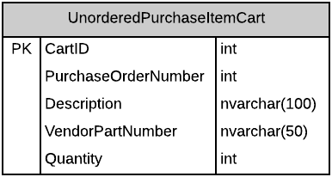

**Add Unordered Vendor Parts** (<asp:LinkButton>)

// Receiving Controller Class

//Add Parts to Unordered Vendor Parts Cart

[DataObjectMethod(DataObjectMethodType.Insert)]

public void AddUnorderedPart(UnorderPart part)

**Remove Unordered Vendor Parts** (<asp:LinkButton>)

// Receiving Controller Class

//Delete Parts from Unordered Vendor Parts Cart

[DataObjectMethod(DataObjectMethodType.Delete)]

public void RemoveUnorderedPart(UnorderPart part)



**Receive Purchase Order**

// Receiving Controller Class

//Process the purchase the order through the bll method, if possible will update the PO to a closed status

public void ReceiveOrder(PurchaseOrderProcessed order) (<asp:Button>)

// Will process the purchase order and will force the Closed bit into true also will store the reason into Notes.

public void ForceClose(PurchaseOrderProcessed order) (<asp:Button>)



